CREATE JAVA APPLICATION

CREATE 2 CLASSES

CLASS 1

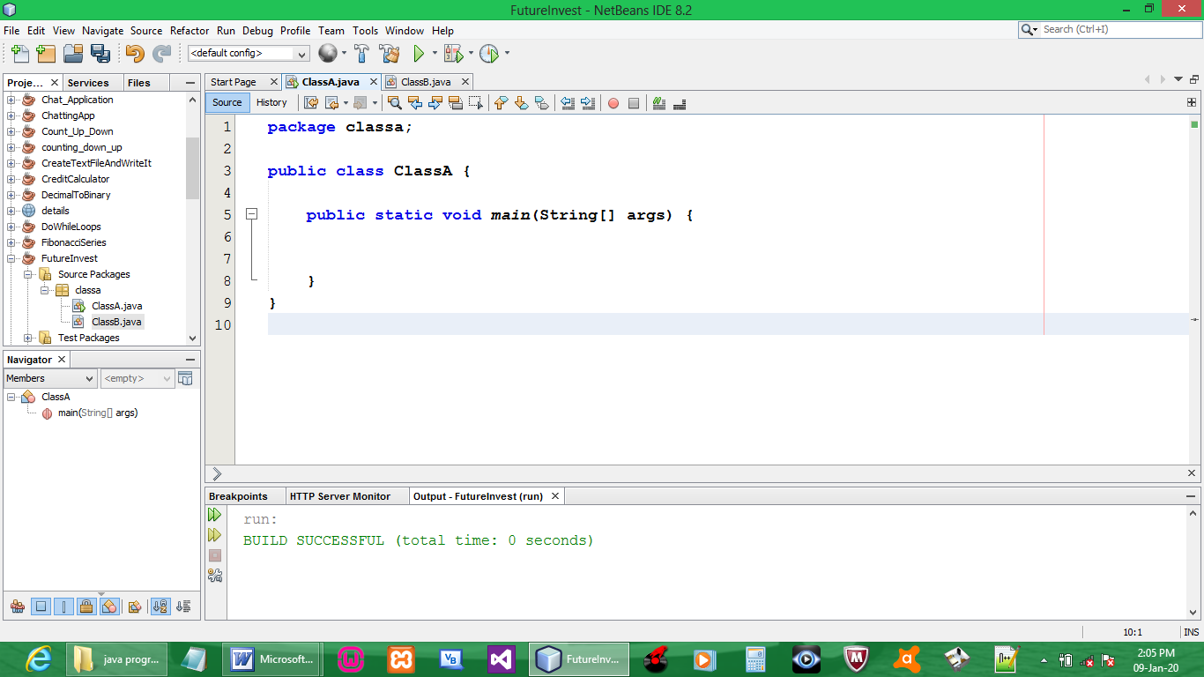

CODE:

package classa;

public class ClassA {

public static void main(String[] args) {
ClassB jvObject = new ClassB();
jvObject.getData();

}
}

CLASS 2

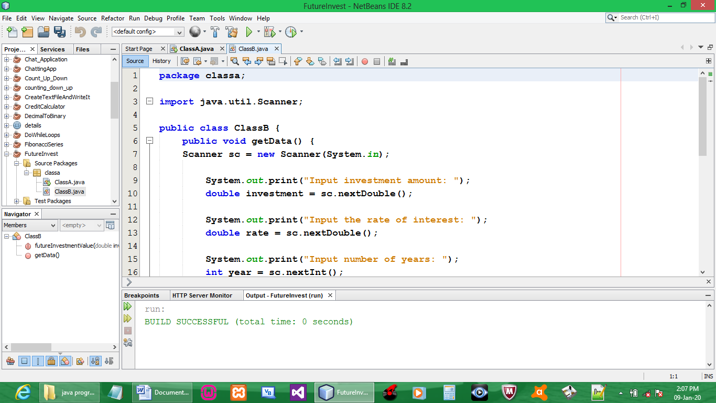

CODE:

package classa;

import java.util.Scanner;

public class ClassB {
public void getData() {
Scanner sc = new Scanner(System.in);

System.out.print("Input investment amount: ");
double investment = sc.nextDouble();

System.out.print("Input the rate of interest: ");
double rate = sc.nextDouble();

System.out.print("Input number of years: ");
int year = sc.nextInt();

rate *= 0.01;

//double futureInvestmentValue

System.out.println("Years FutureValue");
for (int i=1; i<=year; i++){
int aw = 19;
if (i>=10)aw = 18;
System.out.printf(i + "%"+aw+".2f\n", futureInvestmentValue(investment, rate/12, i));
}
}

public static double futureInvestmentValue(double investmentAmount, double monthlyInterestRate, int years){
return investmentAmount * Math.pow(1 + monthlyInterestRate, years*12);
}
}

OUTPUT:

